**Quick Sight Implementation for AI-Driven Social Media Dashboard**

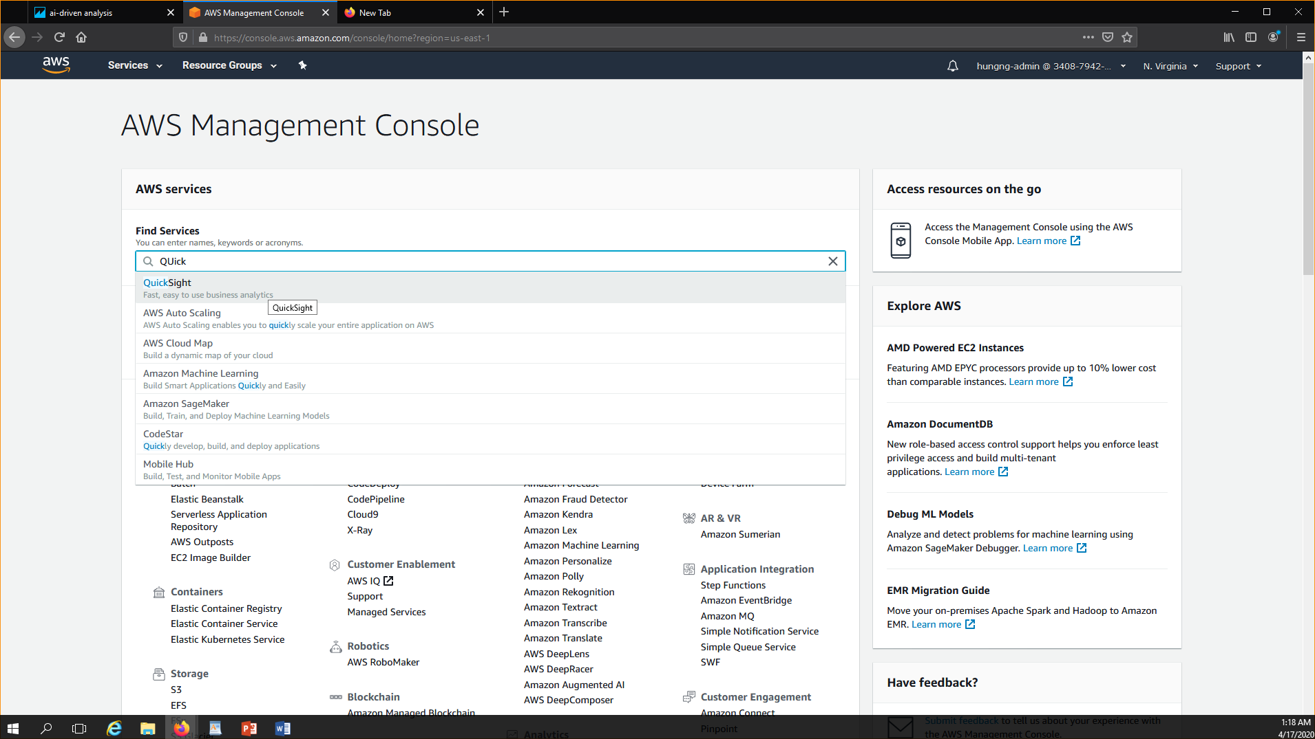

* In AWS management console , search for **“Quick Sight”** service.

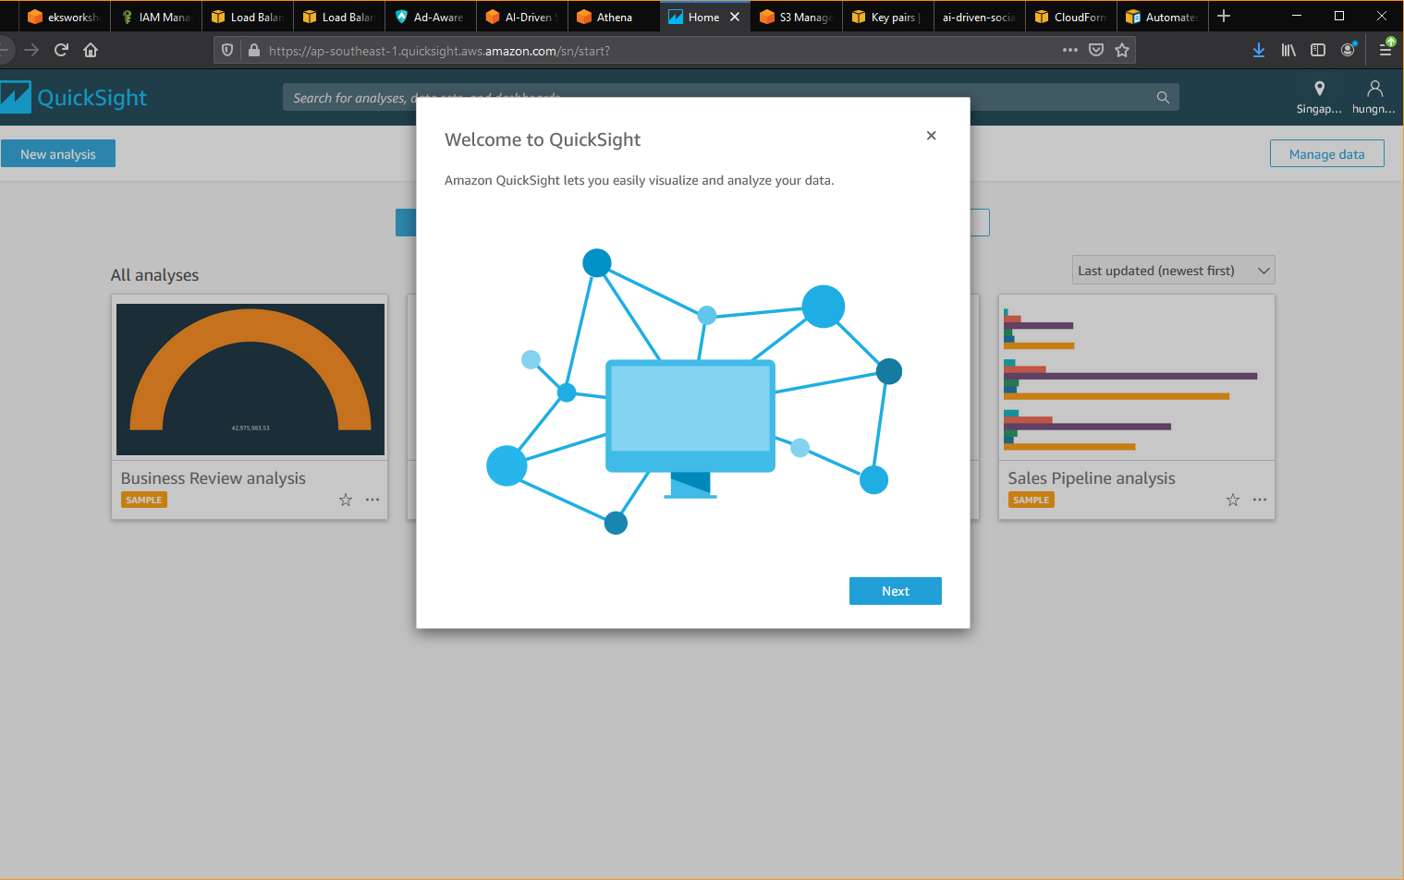

* Click “Next” a few times and click **“Get Started”** button.

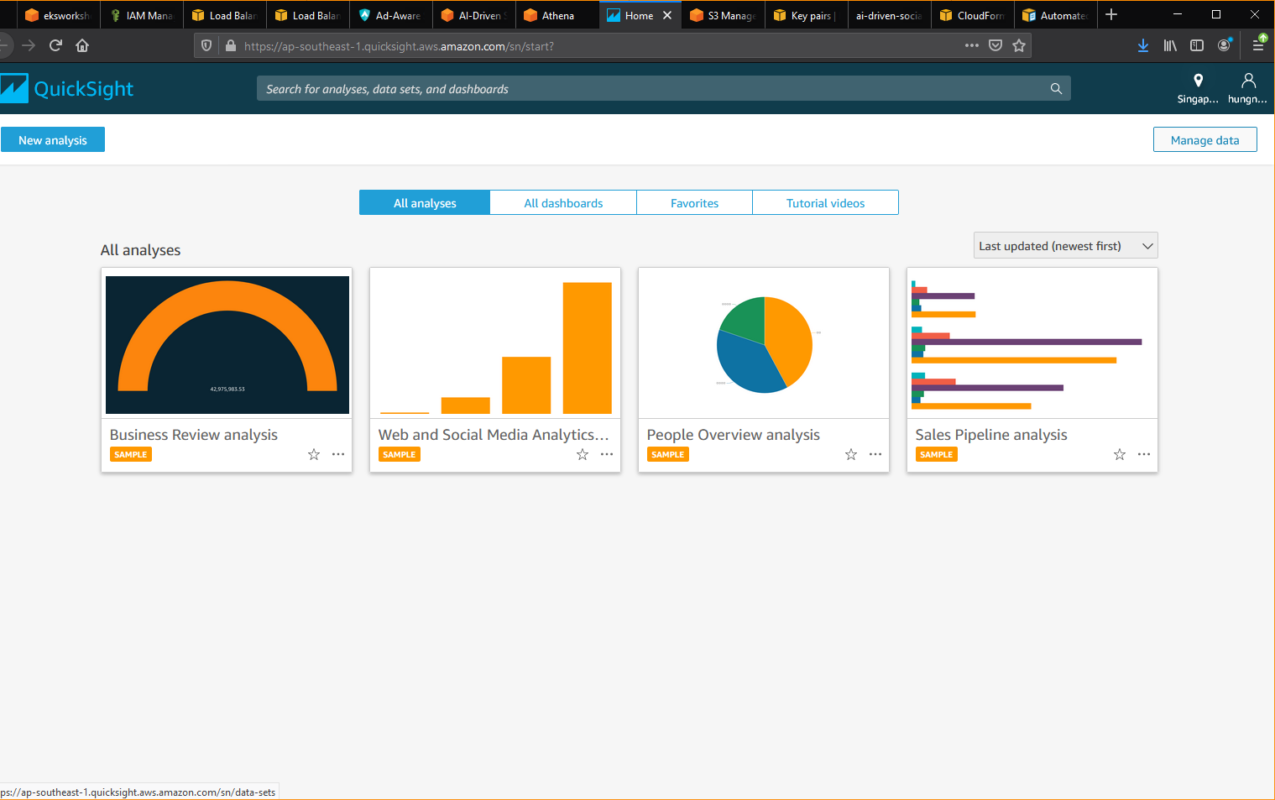

* Click **“Manage Data”** button

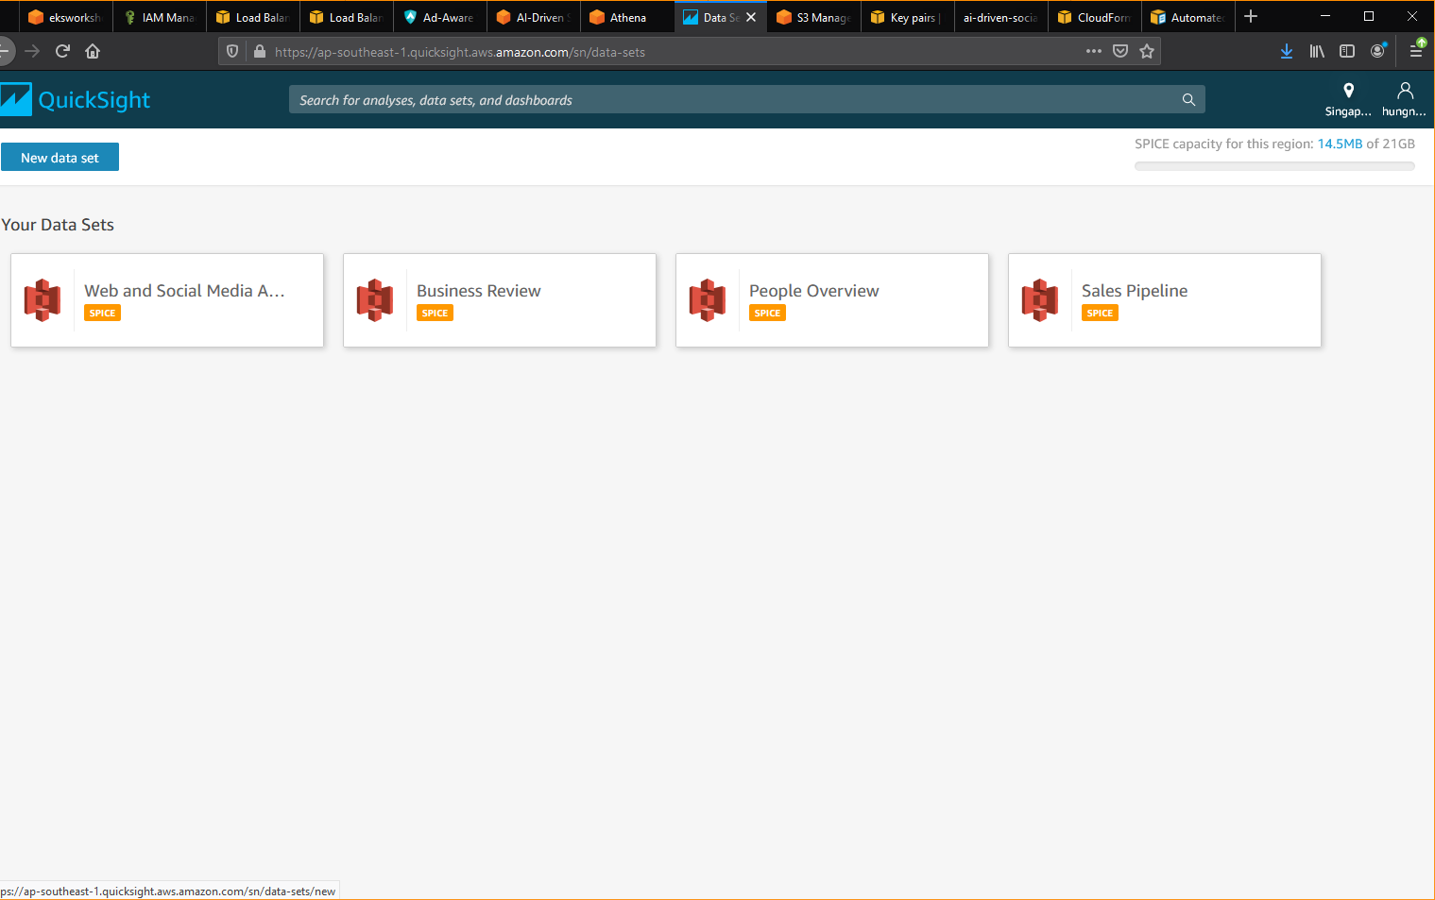

* Click **“New data set”** button.

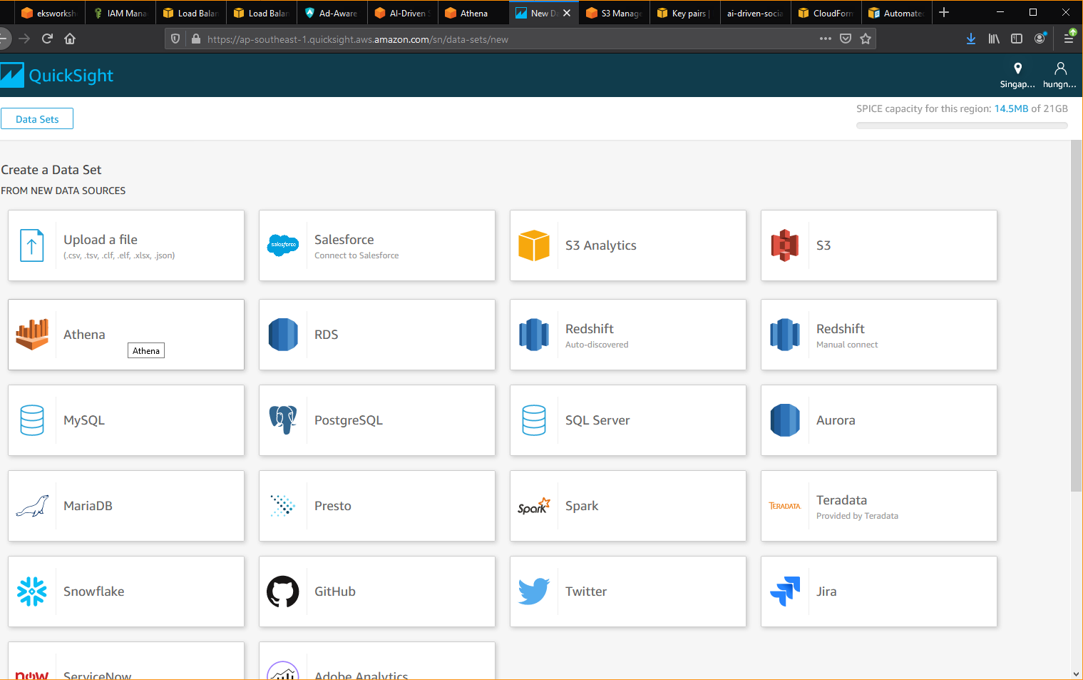

* Select “Athena” to create a data set from Athena.

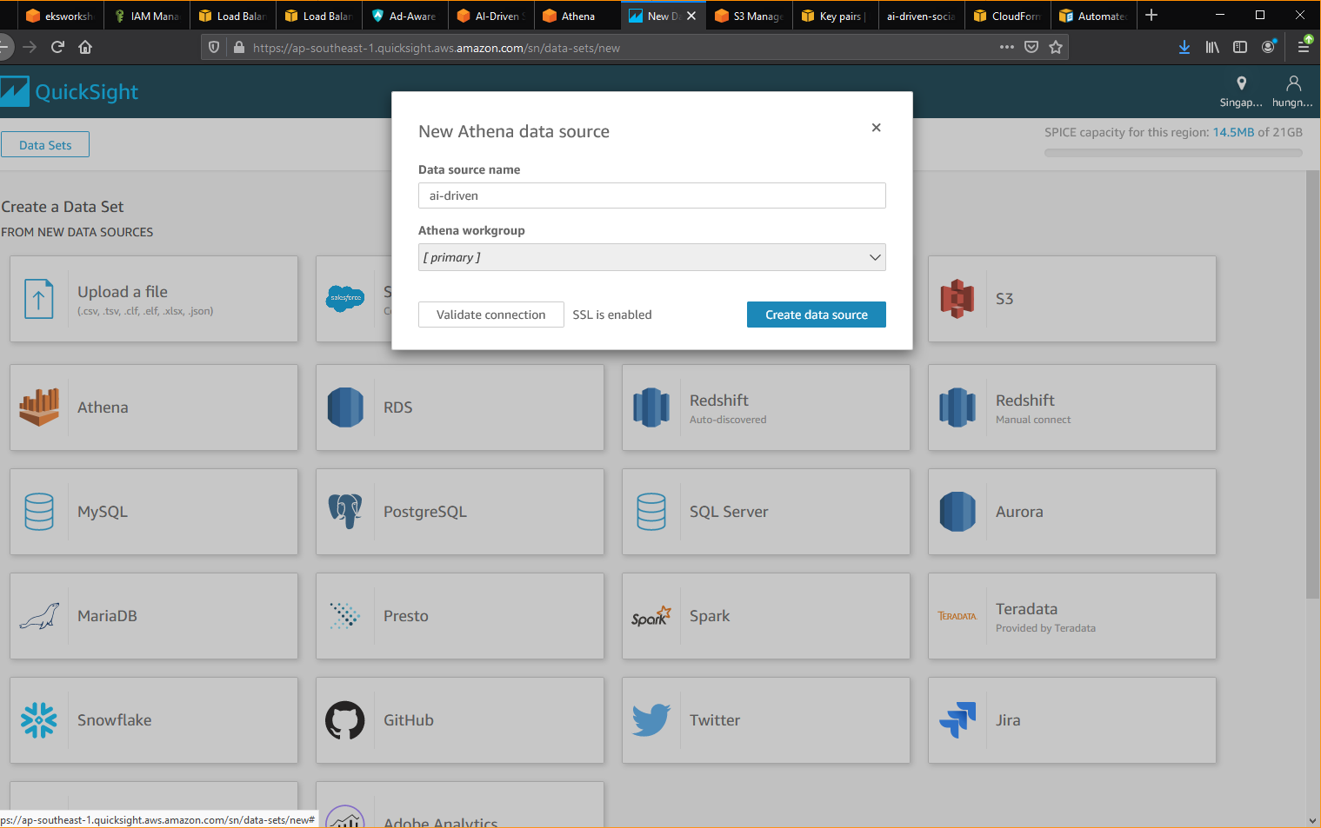

* Enter “ai-driven” or any name based on your desire.
* Select “[primary]” workgroup.
* Click “Create Data Source” button.

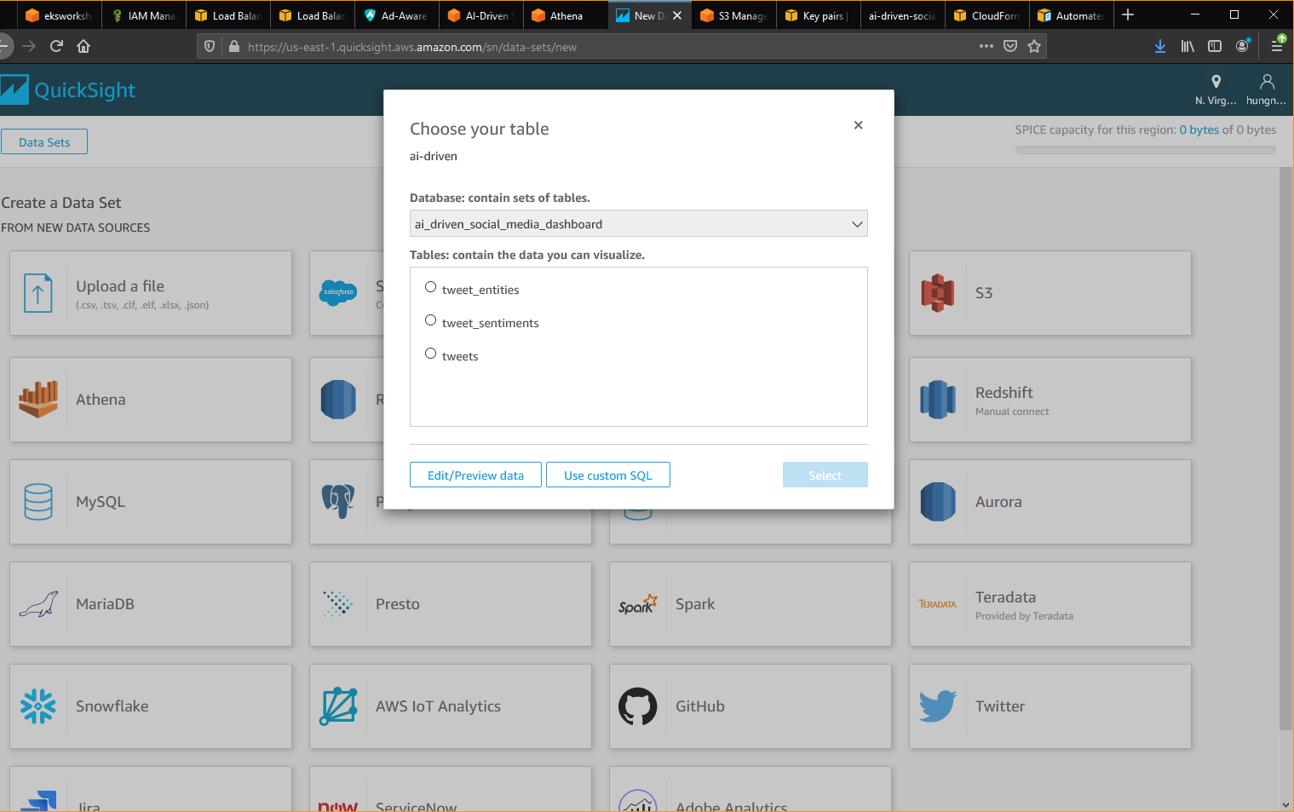

­

* Select “ai_driven_social_media_dashboard” database.
* Select “tweet_sentiment­s”
* Click “Use custom SQL”

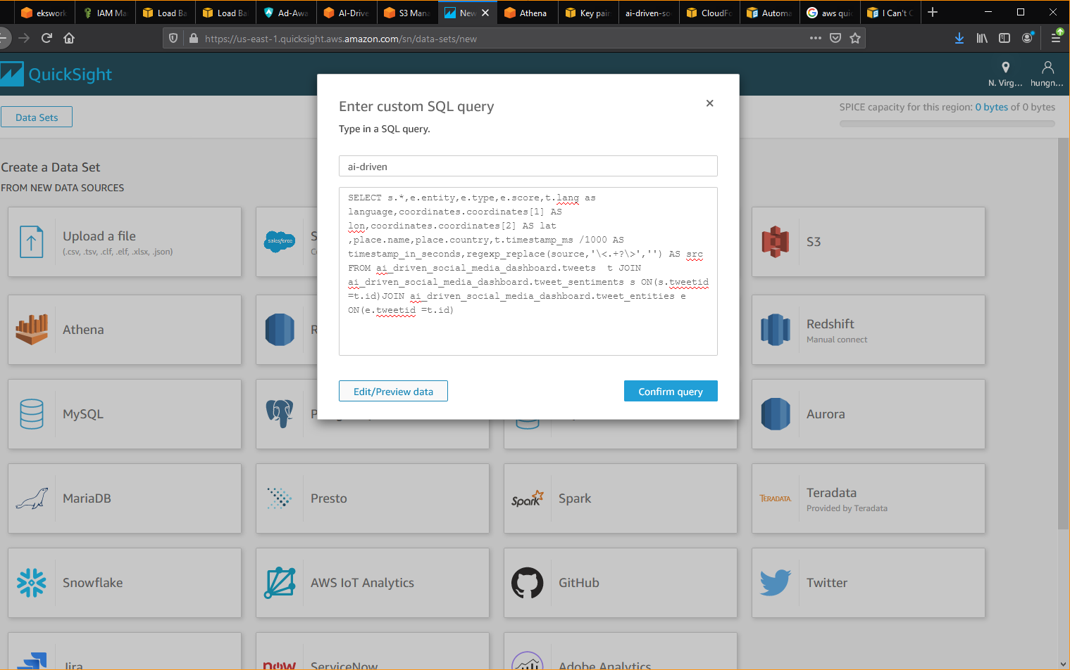

And paste the below SQL into the text field.

|  |
| --- |
| SELECT s.*,e.entity,e.type,e.score,t.lang as language,coordinates.coordinates[1] AS lon,coordinates.coordinates[2] AS lat ,place.name,place.country,t.timestamp_ms /1000 AS timestamp_in_seconds,regexp_replace(source,'\<.+?\>','') AS src FROM ai_driven_social_media_dashboard.tweets t JOIN ai_driven_social_media_dashboard.tweet_sentiments s ON(s.tweetid =t.id)JOIN ai_driven_social_media_dashboard.tweet_entities e ON(e.tweetid =t.id) |

* Click **“Edit/Review Data”.**

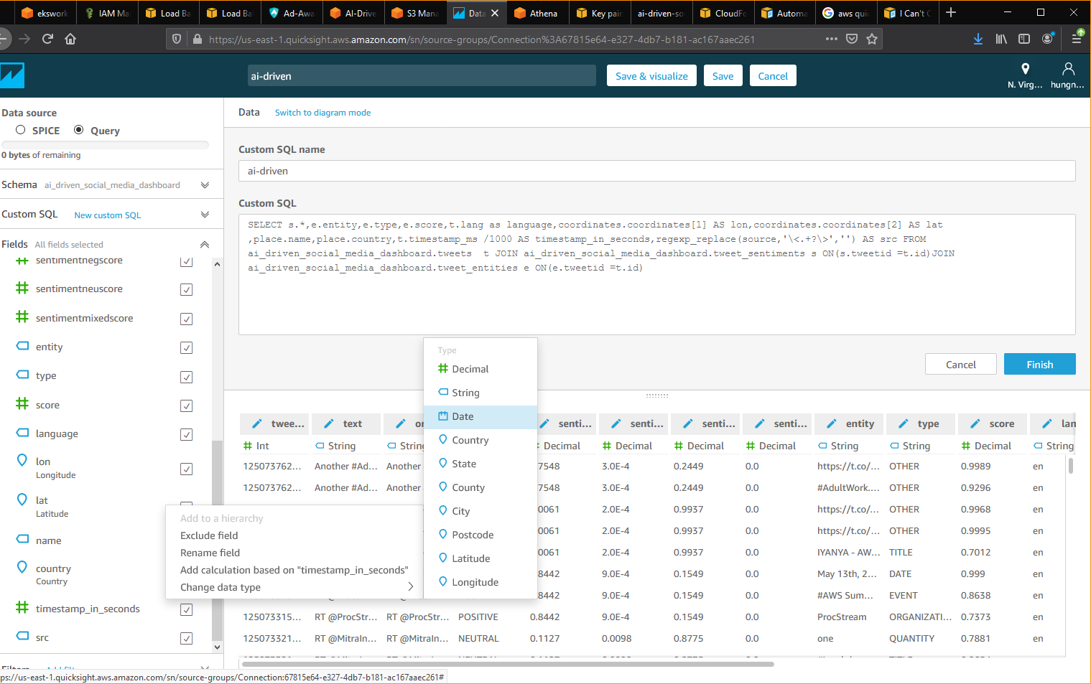

* In “Fields” panel , select “timestamp_in_seconds” Select “Change data type” , select “Date”.
* Click Save and Close,

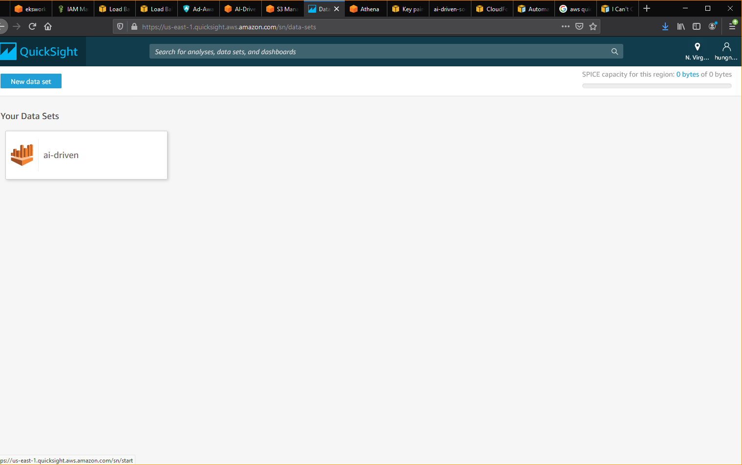

Click “Quick Sight” icon to go back to Quick Sight home.

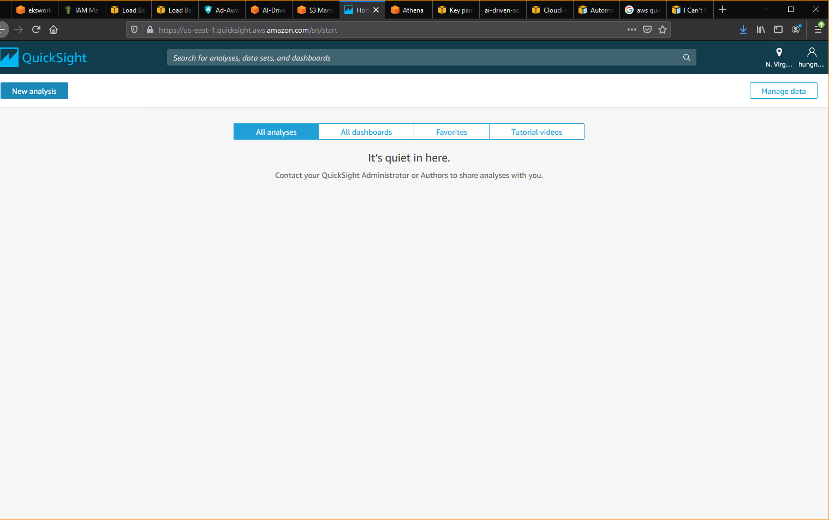

* Click “New Analysis” button to add new analysis

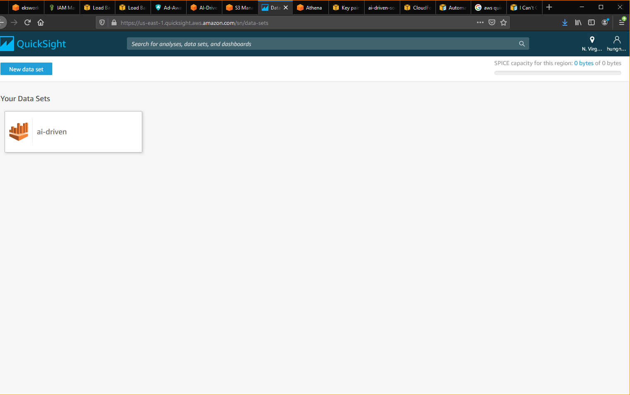

* Click on ai-driven data set.

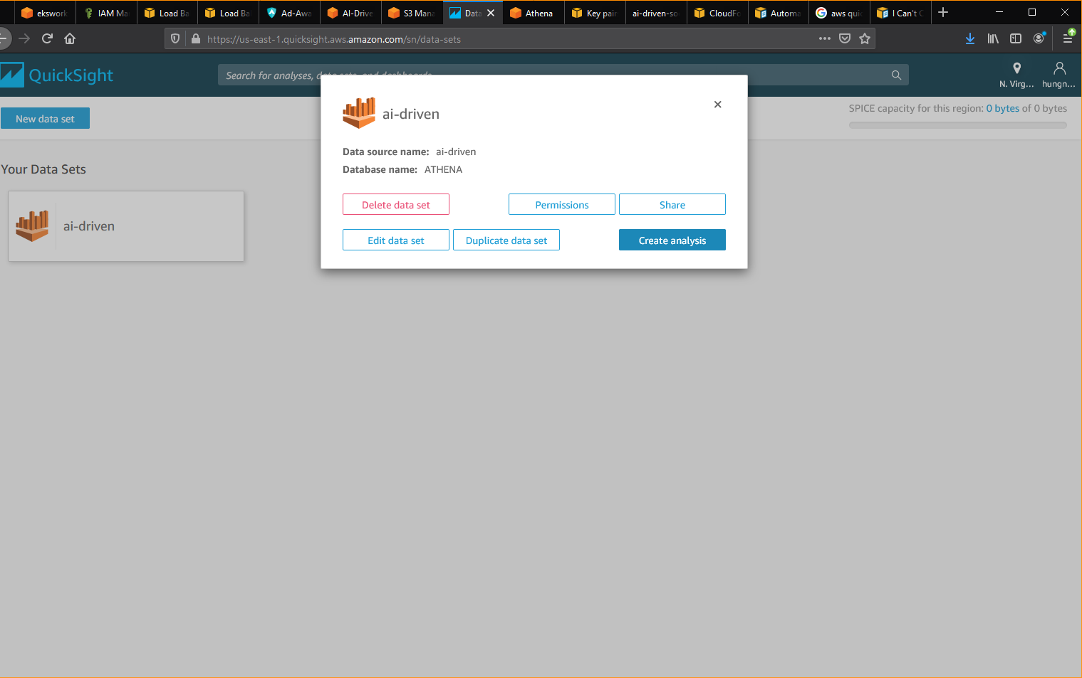

* Click “Create analysis” button.

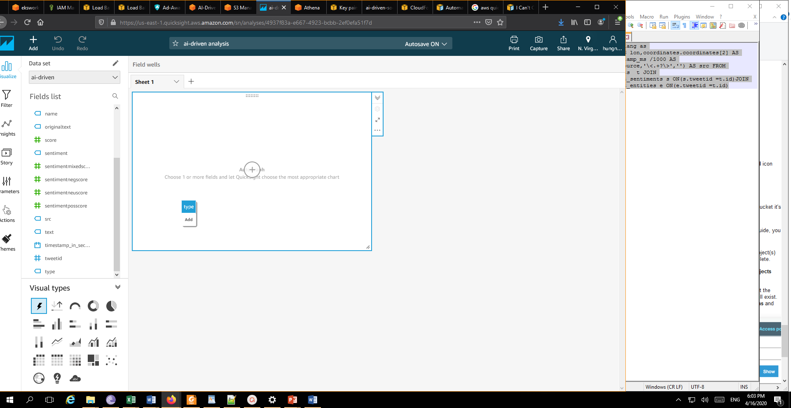

* On the left “Fields list” panel, drag and drop “tweeted” and “type”.

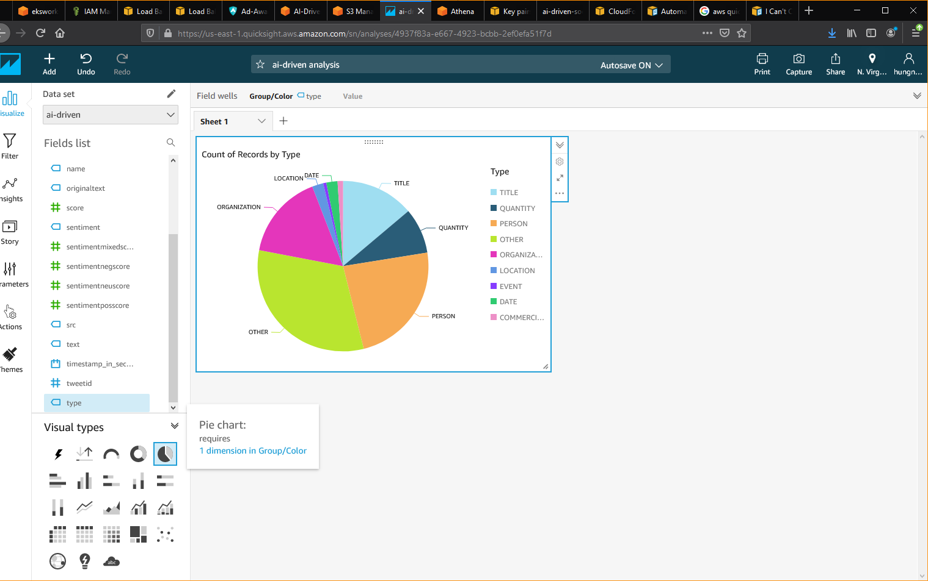

* On “Visual types” panel, select “Pie chart” to start visualize the count number of “tweet id” based on “type” visualization.

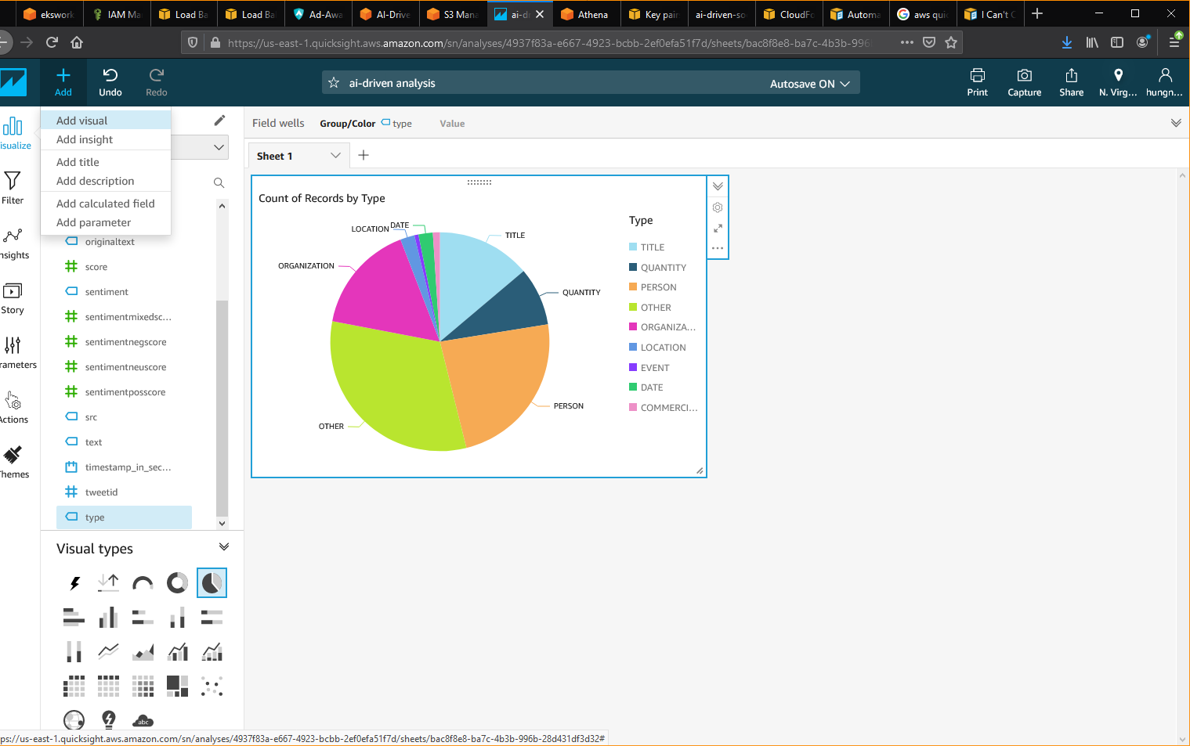

* Click “Add” button on the top menu, select “Add visual” to add new visual.

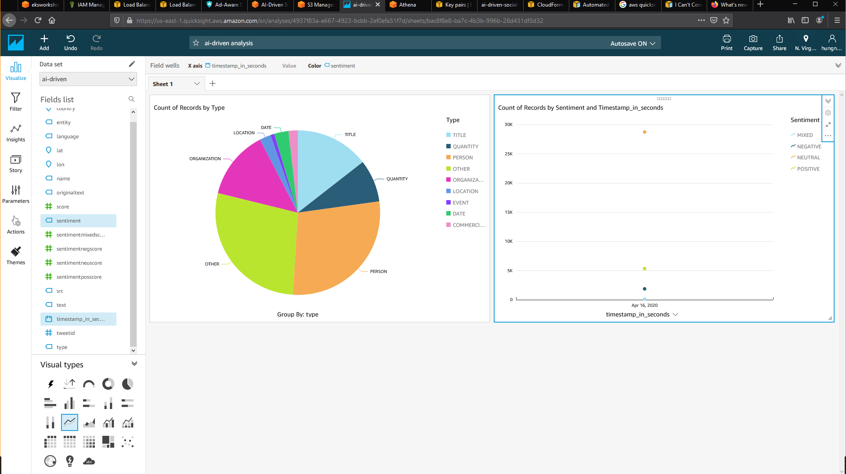

* In the Fields list pane, select the drop-down menu and select “sentiment” and “timestamp_in_seconds”.
* Select Line Chart in the Visual type panel.

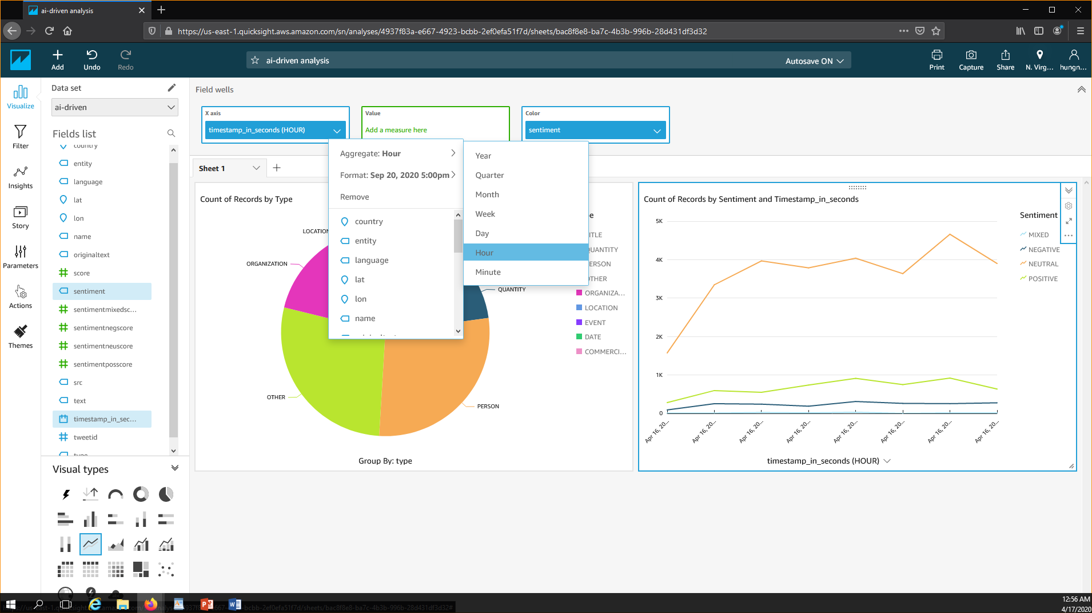

* In the Field wells , zoom in the time to hour.

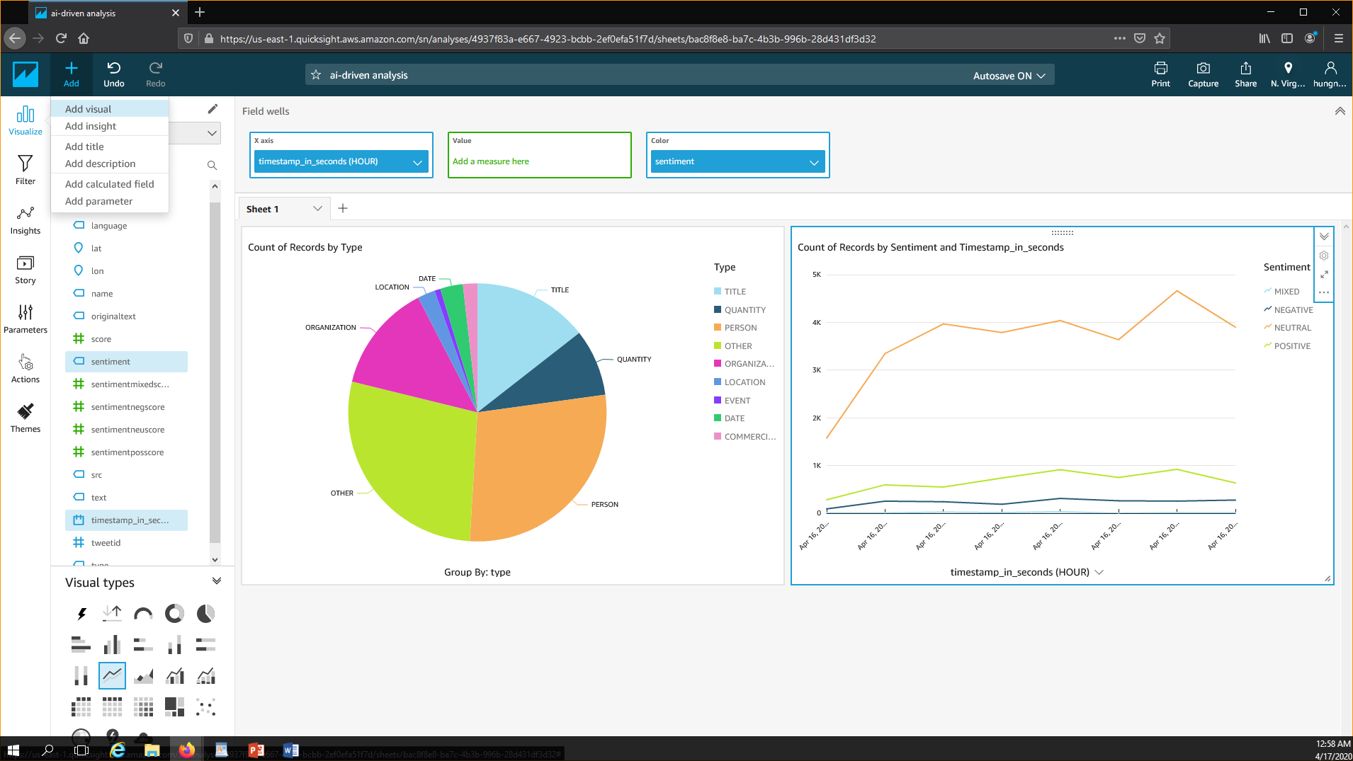

* Select + Add option to build the third visual for the dashboard.

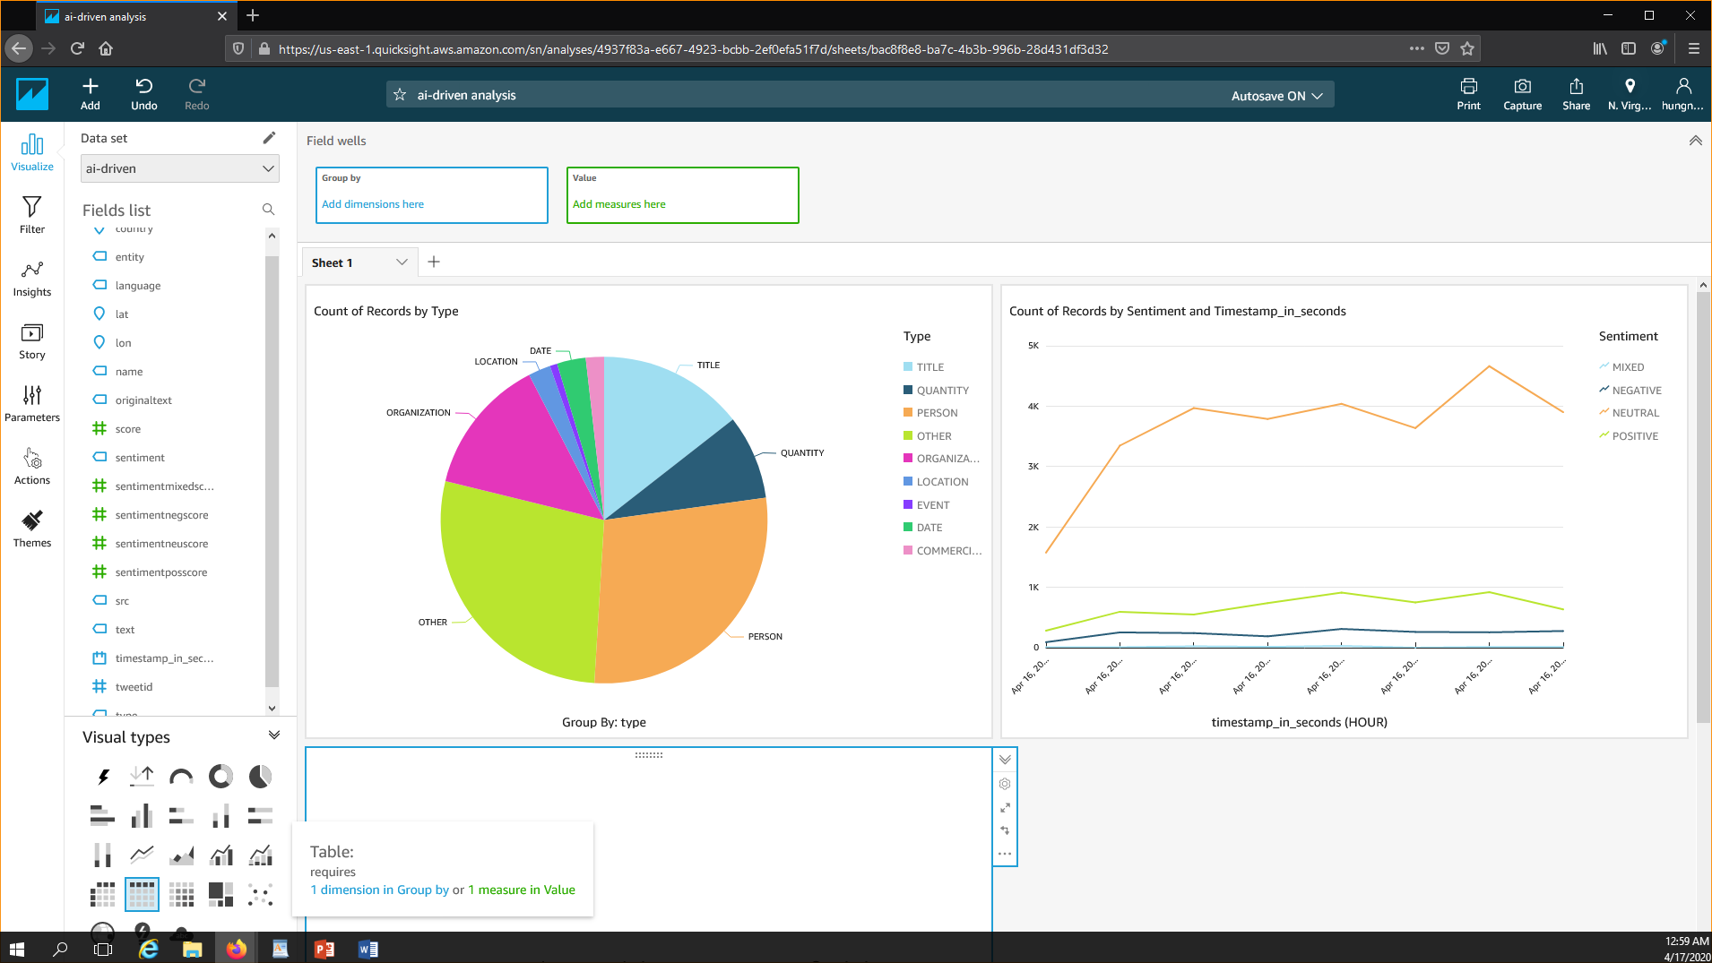

* For Visual Types select “Tables”

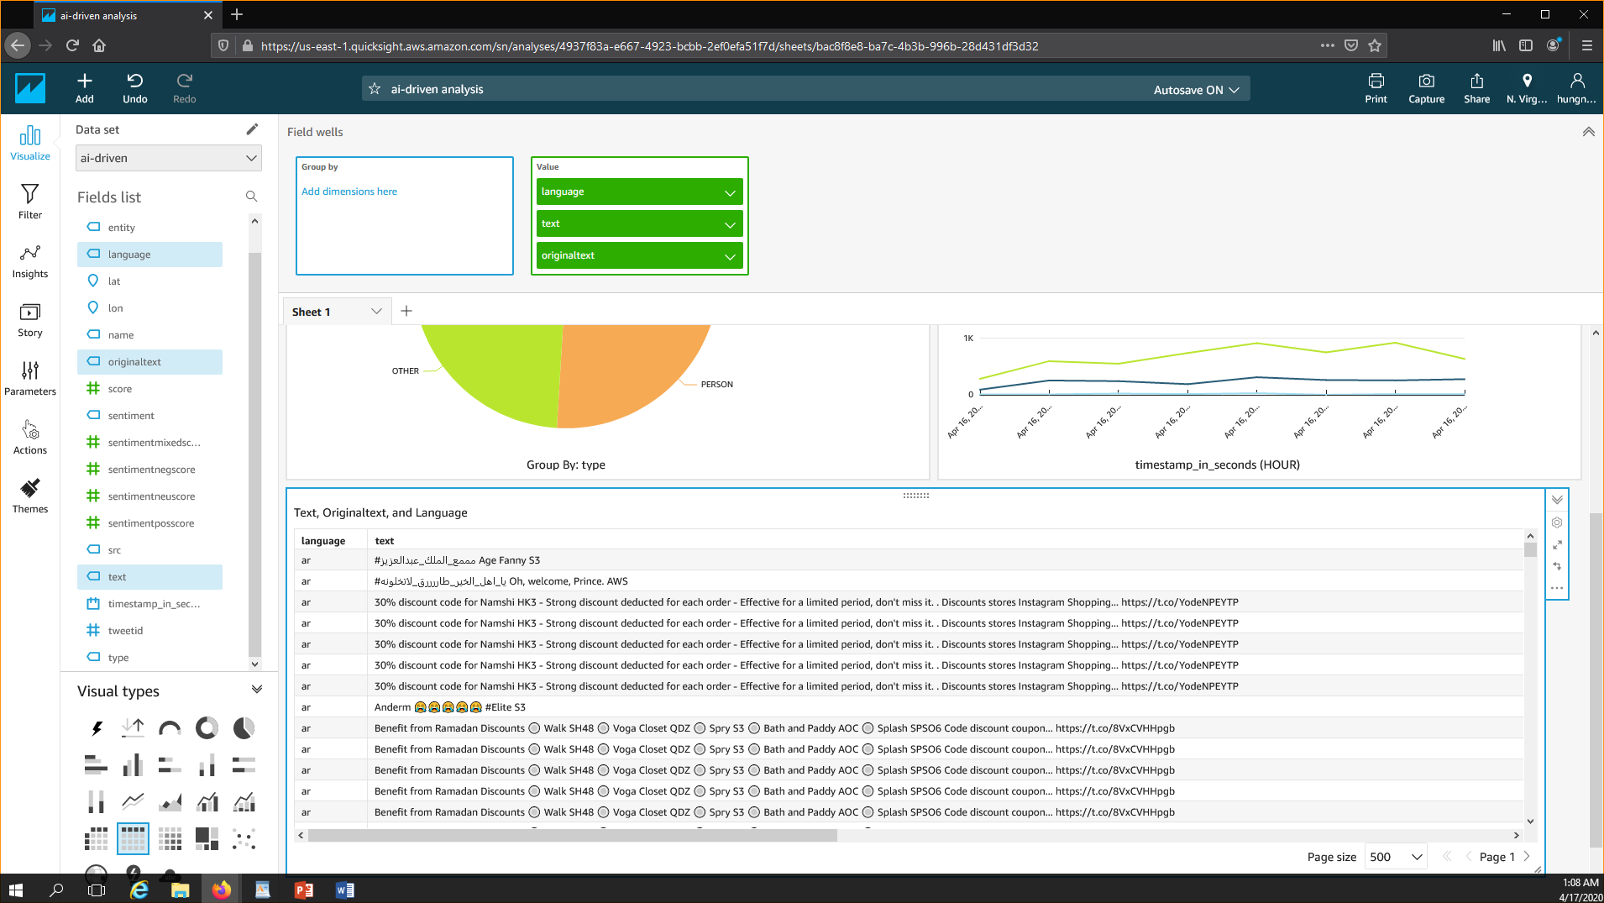

* From the “Fields” list, drag and drop the following field, “language”,”text”, “originalText”.
* Make sure you drag the “Fields” to the Value Box in the Field wells.

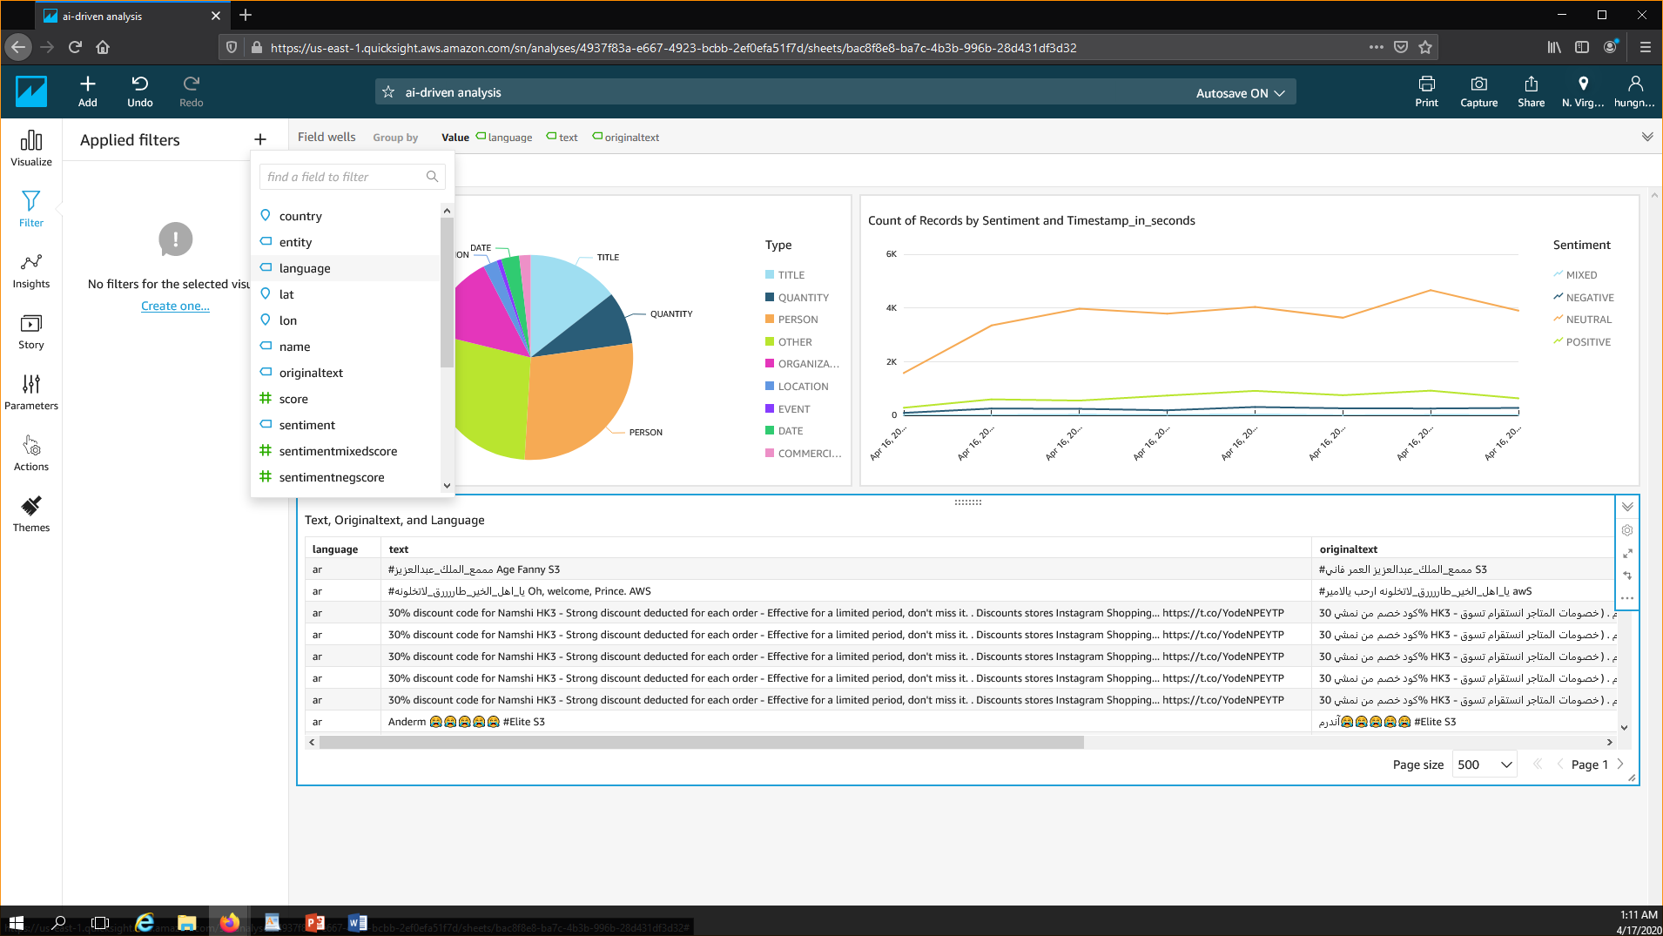

* On the left panel , click “Filter” > Create One > select “language”.

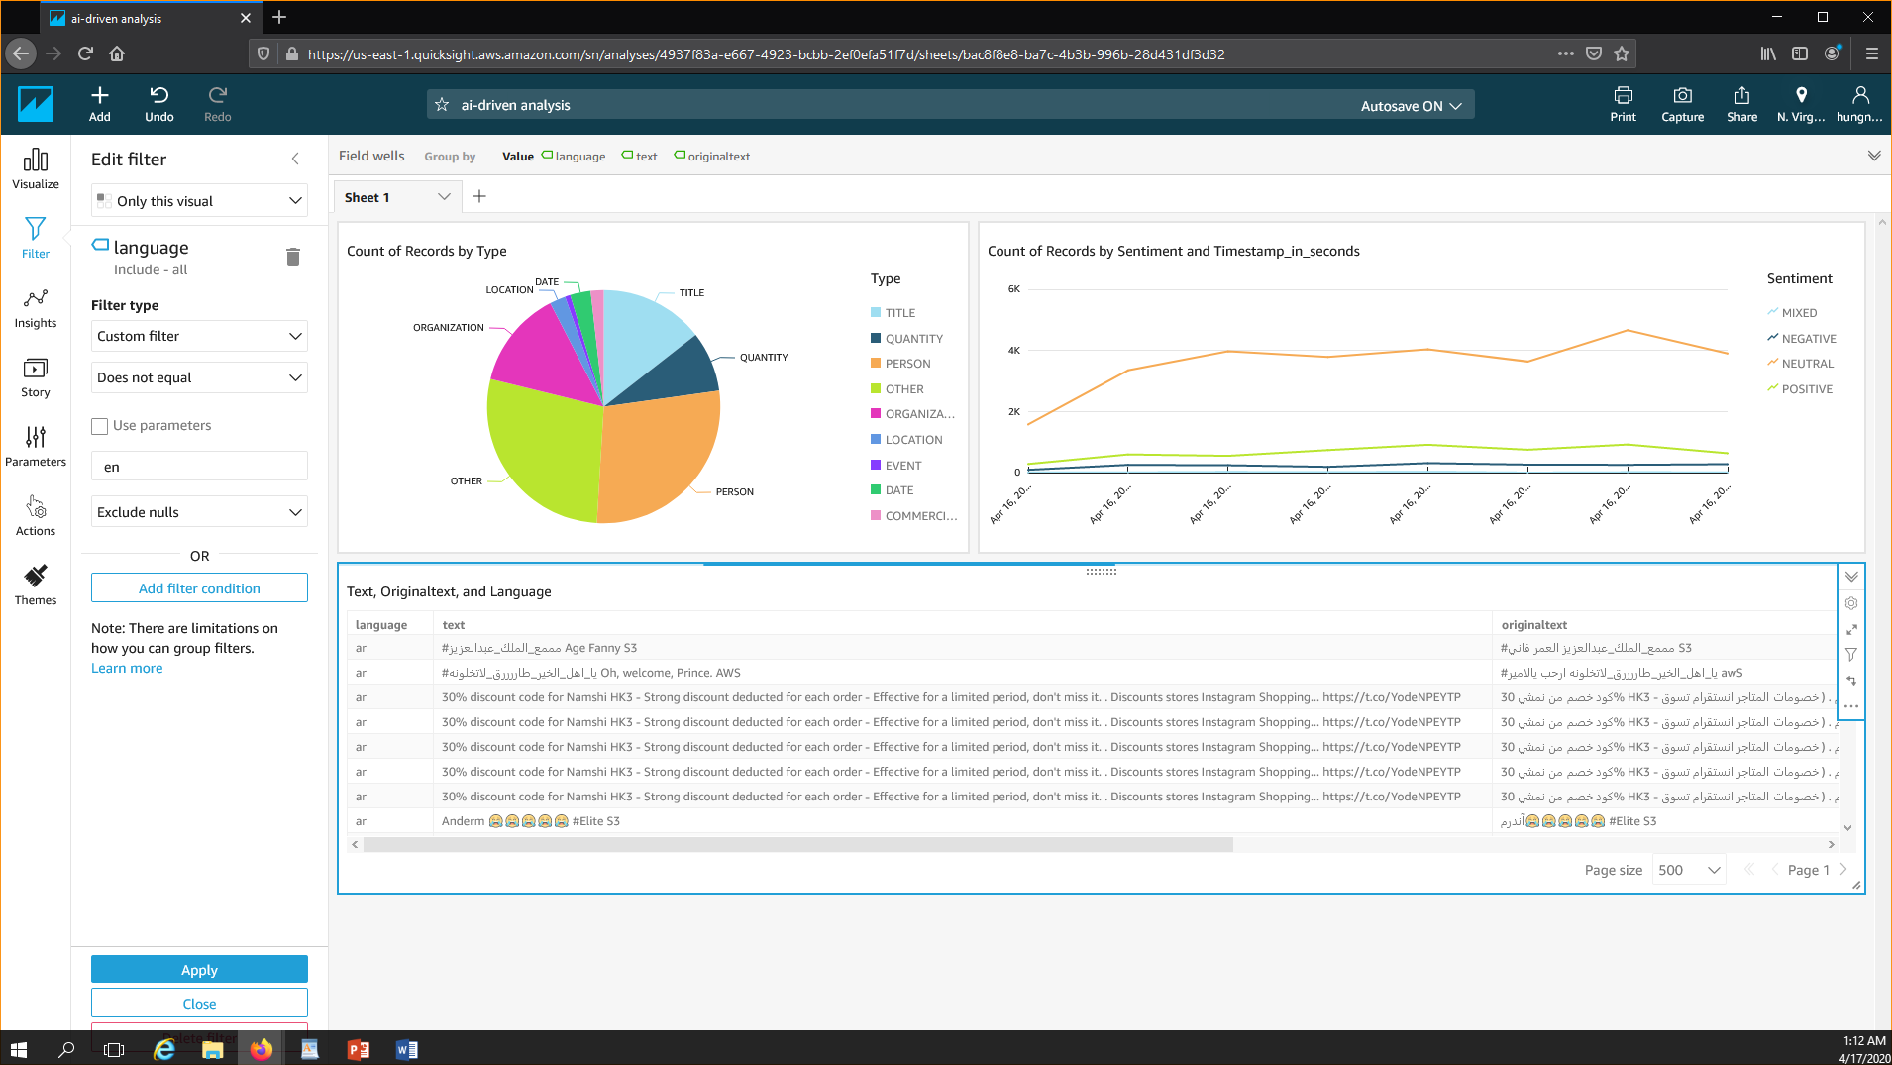

* Select **“Customer Filter”** type, select **“Does not equal”**, and enter **en**.
* Click **“Apply Filter Condition”**

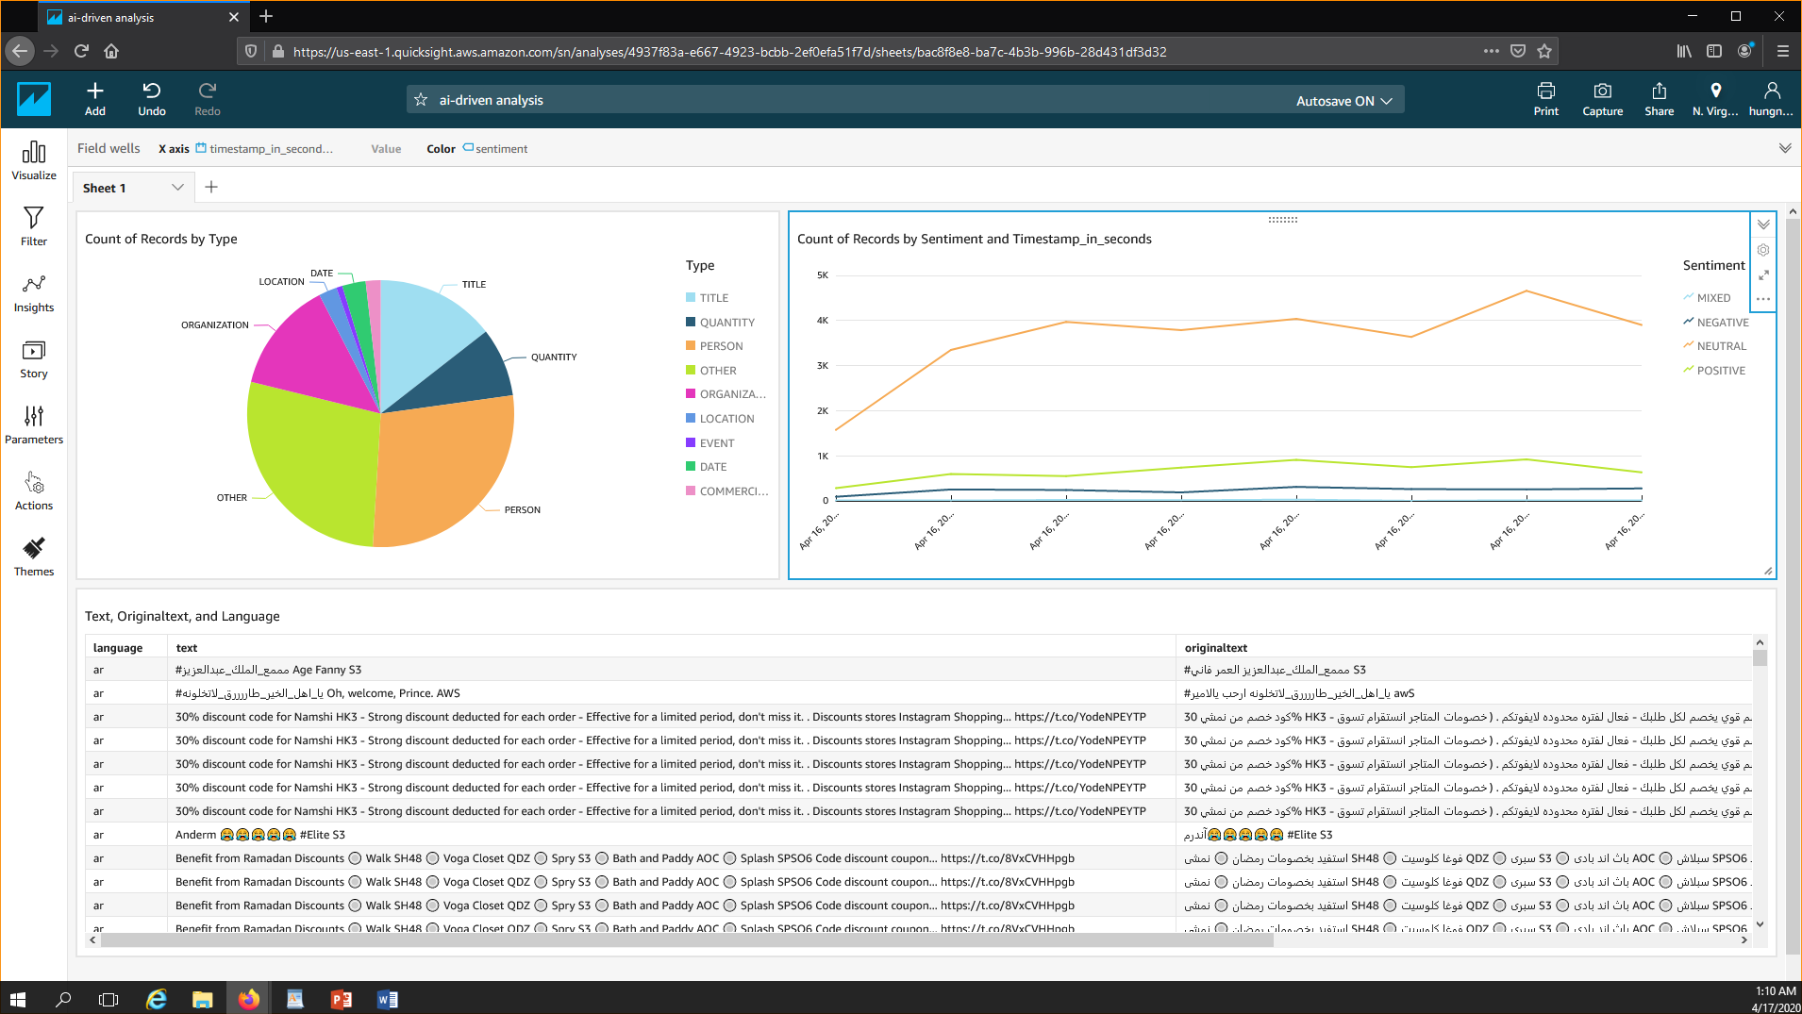

* Finally we have the dashboard to view graphical representations of your tweet entities, tweet sentiment over time, and translated tweets.